  40 Woodlands Drive  Thornlands Qld 4164  Ph: (07) 3206 4177  Fax: (07) 3206 0081  Email: registrar@ntc.edu.au | Assignment  Cover Sheet
 | DATE/TIME RECEIVED

Please complete all sections below and attach to the front of your assignment before electronically submitting. No assignments will be graded without a completed cover sheet.

Student Name: Click here to enter text. | Student Number: Click here to enter text.
Degree Enrolled: Click here to enter text. | Unit Lecturer’s Name: Click here to enter text.
Unit Name: Click here to enter text. | Unit Code: Click here to enter text.
Assessment Title: Click here to enter text. | Due Date: Click here to enter a date.
Required Word Count: Click here to enter text. | Actual Word Count: Click here to enter text.
DECLARATION
I, Click here to enter text. declare that,

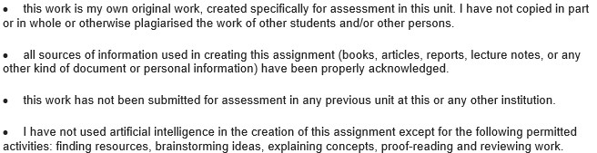

Signed: Click here to enter text. (By typing your name you agree that this electronic signature is the legal equivalent of your manual signature.) Date: Click here to enter a date.
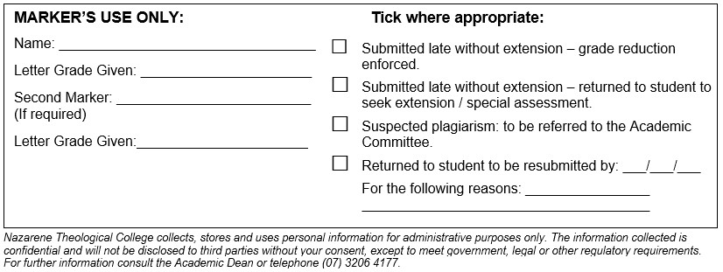
Assignment Title
(Beginning writing here. Keep this font [Times New Roman] and size [12]. Keep the text double-spaced.
Before submitting document, fill in the fields of the Cover sheet and save full document as a PDF. When you save the document, save with the following naming convention:
NTC Unit Code First Initial and Surname Assessment Type Year. Trimester
Example: NTC B7010 J Smith Essay 2025.1)

Bibliography
(Bibliography should be on its own page and should only include works that have been cited in the paper. Do not list dictionaries, encyclopaedia, general surveys, or other such works in your bibliographies (unless it is specifically requested in the assessment task). They are useful as starting points, especially if they give you bibliographical information, but they are too generalized for research essays. Internet sources are useful only if they are scholarly and you can get full bibliographical data on them.
For guides for footnotes and bibliographic citations using Turabian/Chicago style:
https://ntc.edu.au/files/NTC-Footnotes-and-Bibliographies-Form.pdf
http://www.press.uchicago.edu/books/turabian/turabian_citationguide.html )

Notice that the Bibliography page is formatted differently from the rest of the document.
https://ntc.edu.au/images/users/NTC-Footnote-and-Bibliography-Formating-Tips-Turabian.pdf
See examples below.)

Examples:
Gorman, Michael J. Kenosis, Justification, and Theosis in Paul’s Narrative Soteriology. Grand Rapids: Eerdmans, 2009.

Alexander, Loveday. “Hellenistic Letter-Forms and the Structure of Philippians.” Journal for the Study of the New Testament 37:1 (1989): 87-101.

We prefer students use Turabian/Chicago style guidelines but regardless of style selection, it must be consistent throughout the document.

