  40 Woodlands Drive  Thornlands Qld 4164  Ph: (07) 3206 4177  Fax: (07) 3206 0081  Email: registrar@ntc.edu.au | Assignment  Cover Sheet
 | DATE/TIME RECEIVED

Please complete all sections below and attach to the front of your assignment before electronically submitting. No assignments will be graded without a completed cover sheet.

Student Name: Click here to enter text. | Student Number: Click here to enter text.
Degree Enrolled: Click here to enter text. | Unit Lecturer’s Name: Click here to enter text.
Unit Name: Click here to enter text. | Unit Code: Click here to enter text.
Assessment Title: Click here to enter text. | Due Date: Click here to enter a date.
Required Word Count: Click here to enter text. | Actual Word Count: Click here to enter text.
DECLARATION
I, Click here to enter text. declare that,

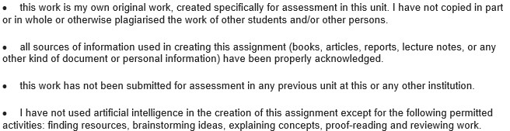

Signed: Click here to enter text. (By typing your name you agree that this electronic signature is the legal equivalent of your manual signature.) Date: Click here to enter a date.
